Procedural RPG

Create an RPG that includes procedural dungeons, leveling/stats system, combat system, and equipment.

The main challenge will be to create a playable game without an updatable screen to draw on and hopefully users will be gamers ready for a refreshing RPG.

TKinter for the GUI and user input.

Objects for many things in the game

Objects

Flow

**Main Menu:**

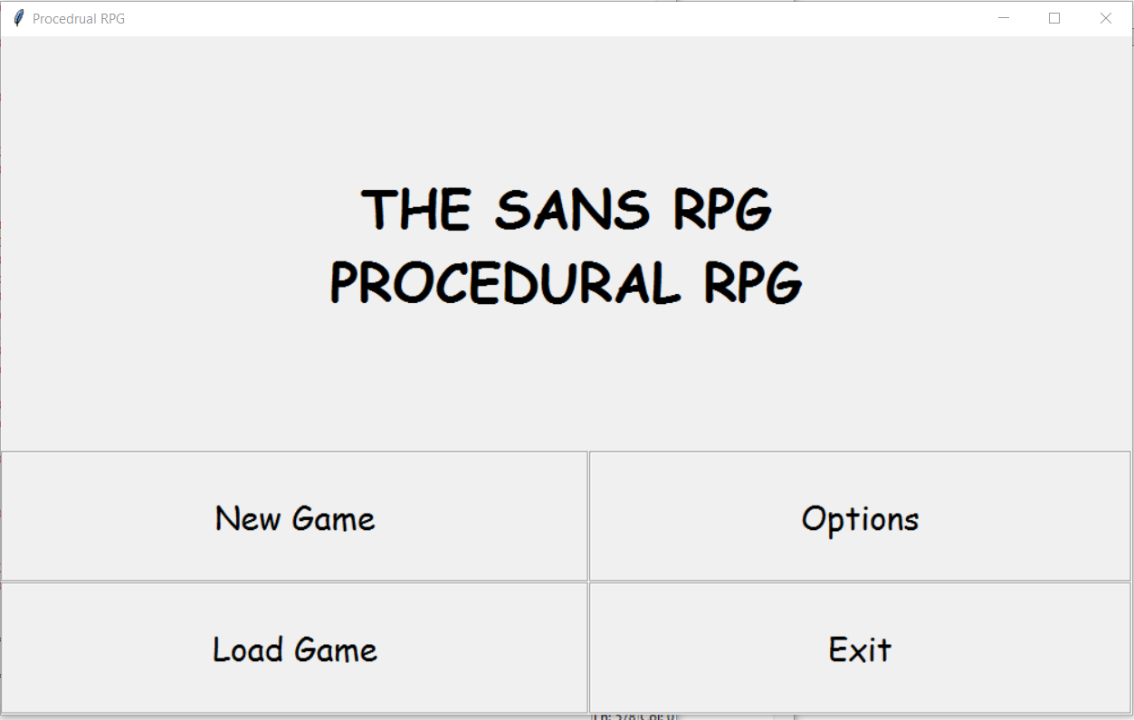

New Game:

Go through character creation

Load Game:

Get all info from save file and load

Options:

NOTHING

Exit:

Close window

**CHARACTER CREATION:**

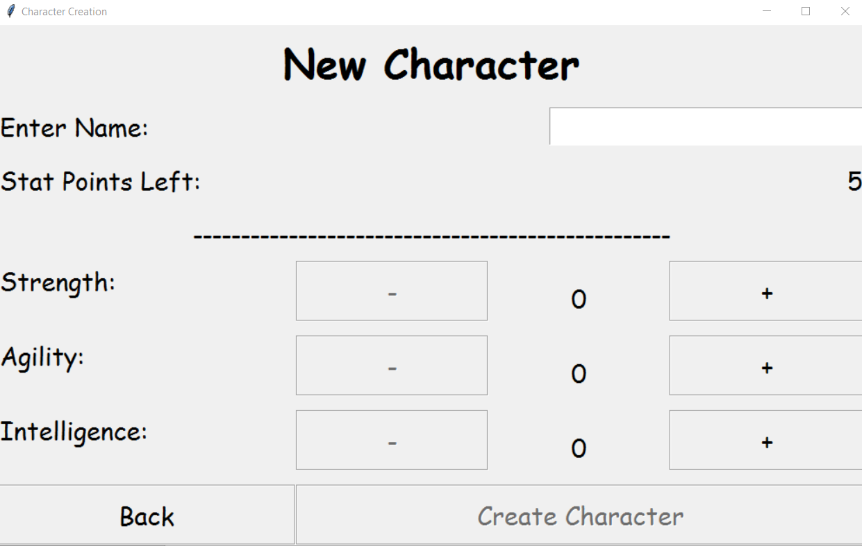

* The 5 stat points can be allocated
* Back returns to main menu
* Create Character starts the game

**TOWN SYSTEM:**

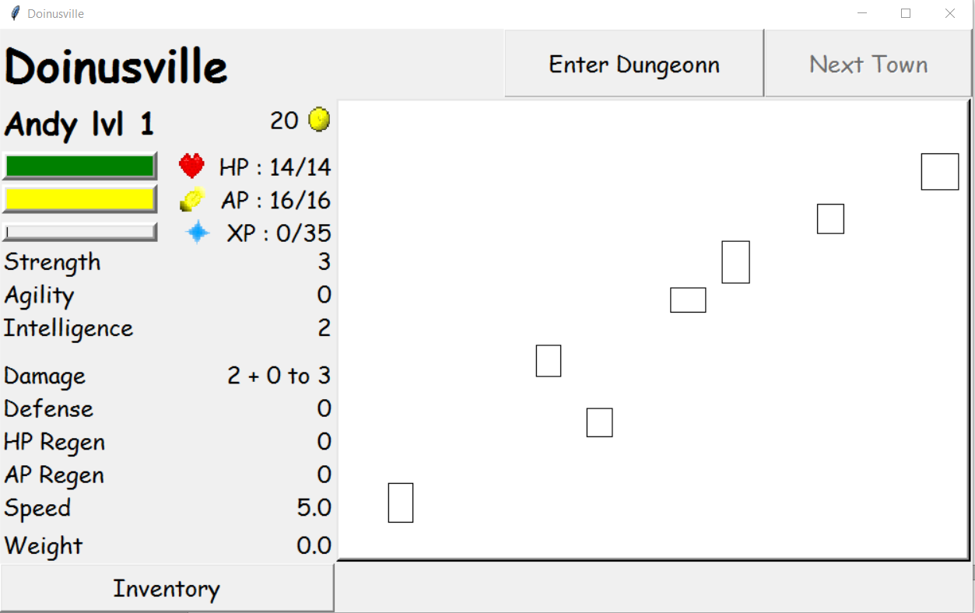

All towns have option to enter the next dungeon, go to the next town, or go to the previous town

Shops of the town are displayed as boxes on a canvas

Town can have at least 3, at most 7 shops:

General Store:

-Holds equipment and food

-Can sell things for ½ price (round down)

Market:

-Food with higher modifier rates

-Cheaper than general store

Inn:

-Sleep (recover all AP and health for 10 gold)

Healer:

-Heal all HP and AP for price/point rate

Blacksmith:

-Modifiers armor/weapons

-Chance for modifier at price/chance rate

Arena:

-Gain xp and money based on STR

Archery Range:

-Gain xp and money best on AGI

Library:

-Gain xp and money based on INT

Some shops have a UI, some are just a button

**DUNGEON SYSTEM:**

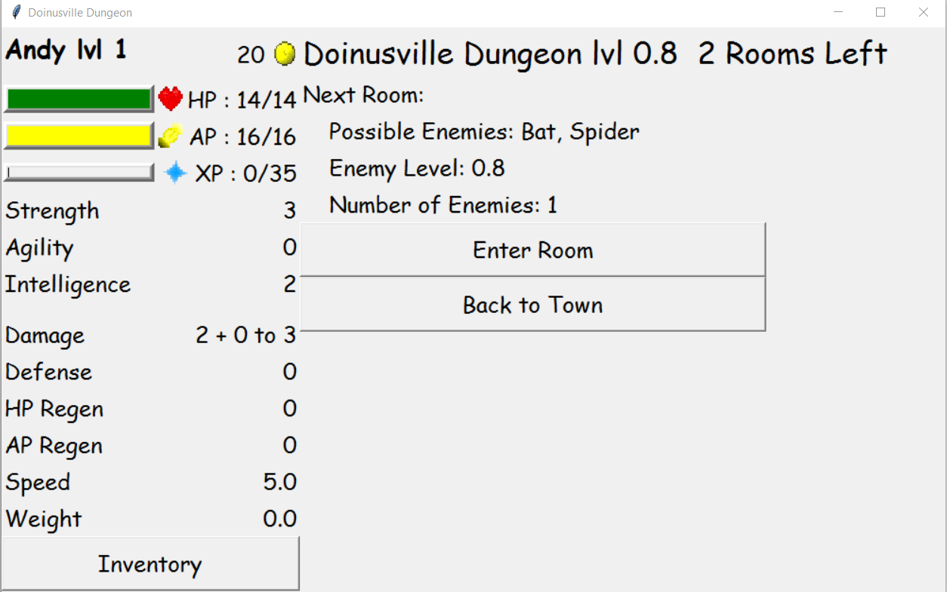

The dungeon system will be based off of a system I used in a project I did for fun about a year ago.

Each Dungeon will contain an array of rooms:

**ROOMS:**

Each room will have a name, number of enemies, loot chance, possible loot, and xp value

Room will be able to run and get a piece of loot out of the loot list

Each Dungeon will also contain an array of Enemies

The dungeon will pick a room out of the room array and run it

**LOOT SYSTEM:**

When a piece of equipment is generated as loot, it will have x number of chances to get a modifier, where x is increased by 1 for every 3 player levels. Each chance, the computer will pick one modifier from the list of all of them, and test to see if a random number 0-300 is less than the chance value for each modifier. If it is, the modifier is added. Modifiers are meant to be somewhat rare for equipment, food will use a similar system.

**INVENTORY SYSTEM:**

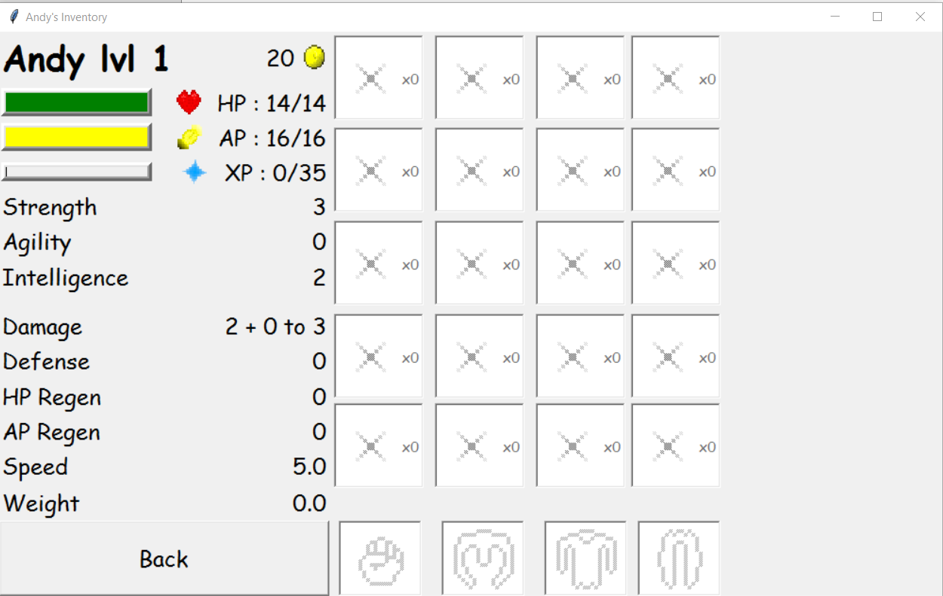

The inventory will be an array of inventory slots. Inventory slots will have an Item and amount. This will allow for stackable items such as food, meaning all items need a Boolean for stackable, similar to Minecraft. There will be 20 (4x5).

**COMBAT SYSTEM:**

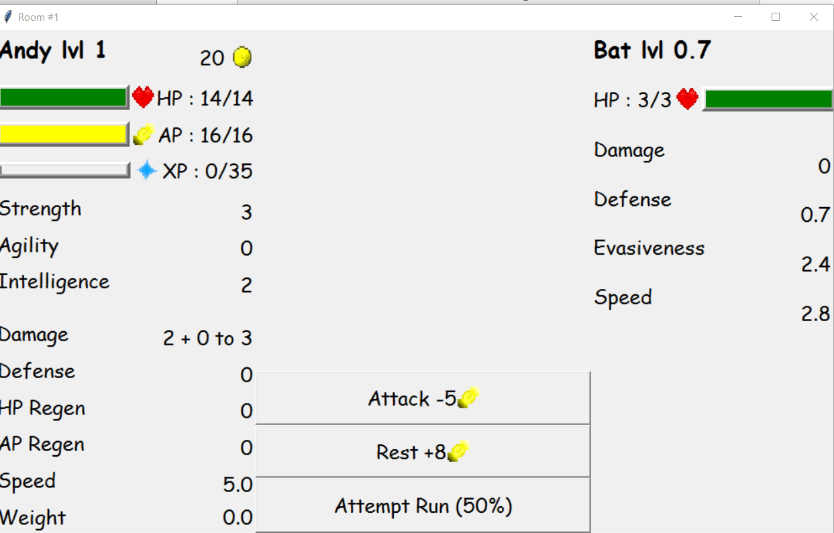

Each room in a dungeon will have an amount of enemies. The player will encounter each enemy in the room one at a time. After an encounter, the player will have the option to fight the next enemy or look in their inventory and use or equip anything. Each enemy will have a chance to drop equipment, food, and other items.